Let me start off by saying I watched the clock to see how long it took for me to do this lab so you can have some data to compare with other students that may have reported how long it took them to do this lab. It took me around 7 hours to complete this lab. Which included me eating while working on the lab and 1 or 2 bathroom breaks. I feel very confident in this lab.

Creating lab

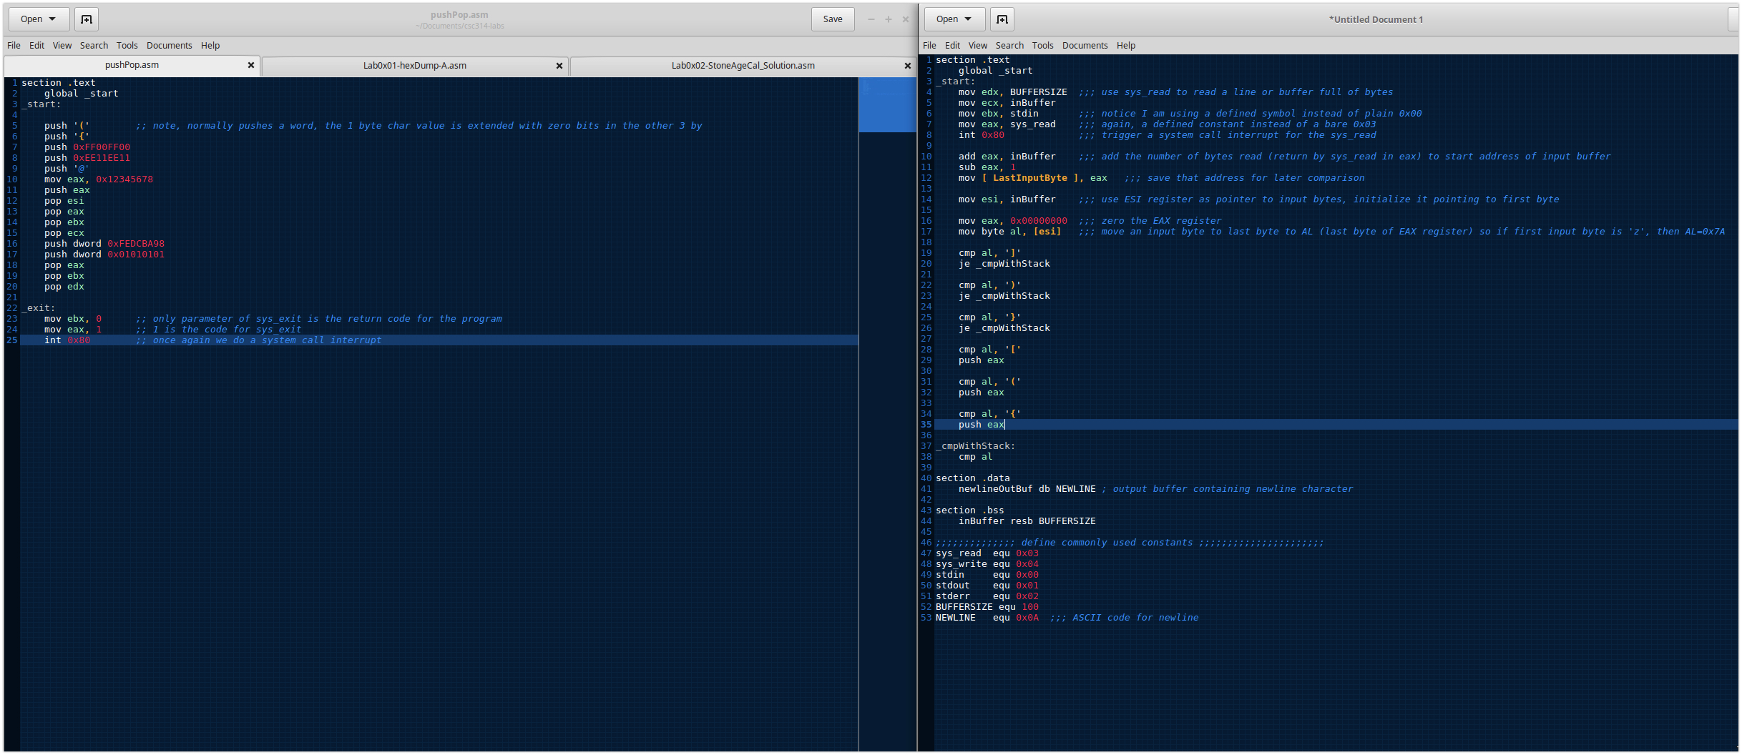

Testing Algorithm

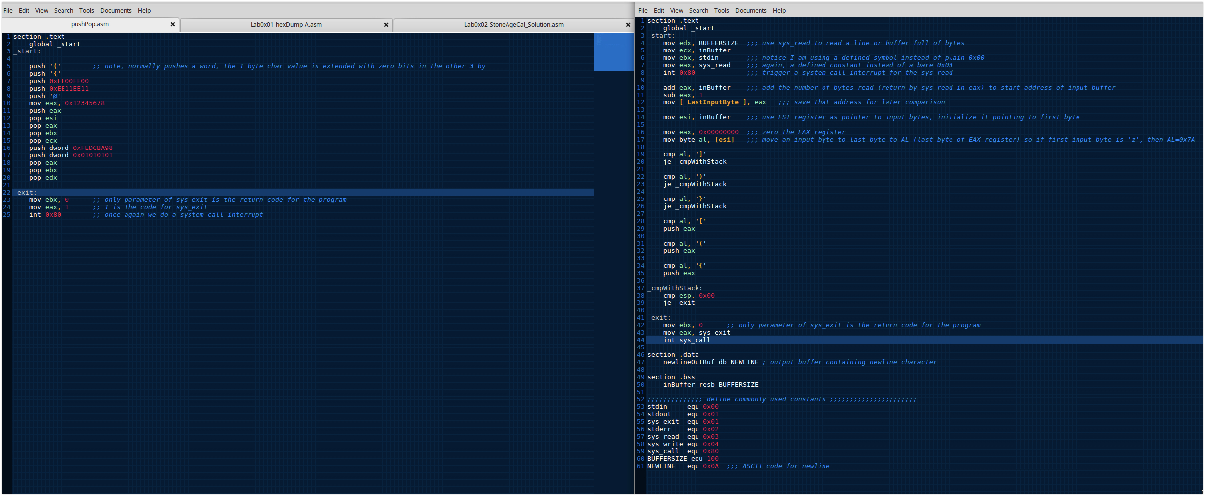

Testing Algorithm

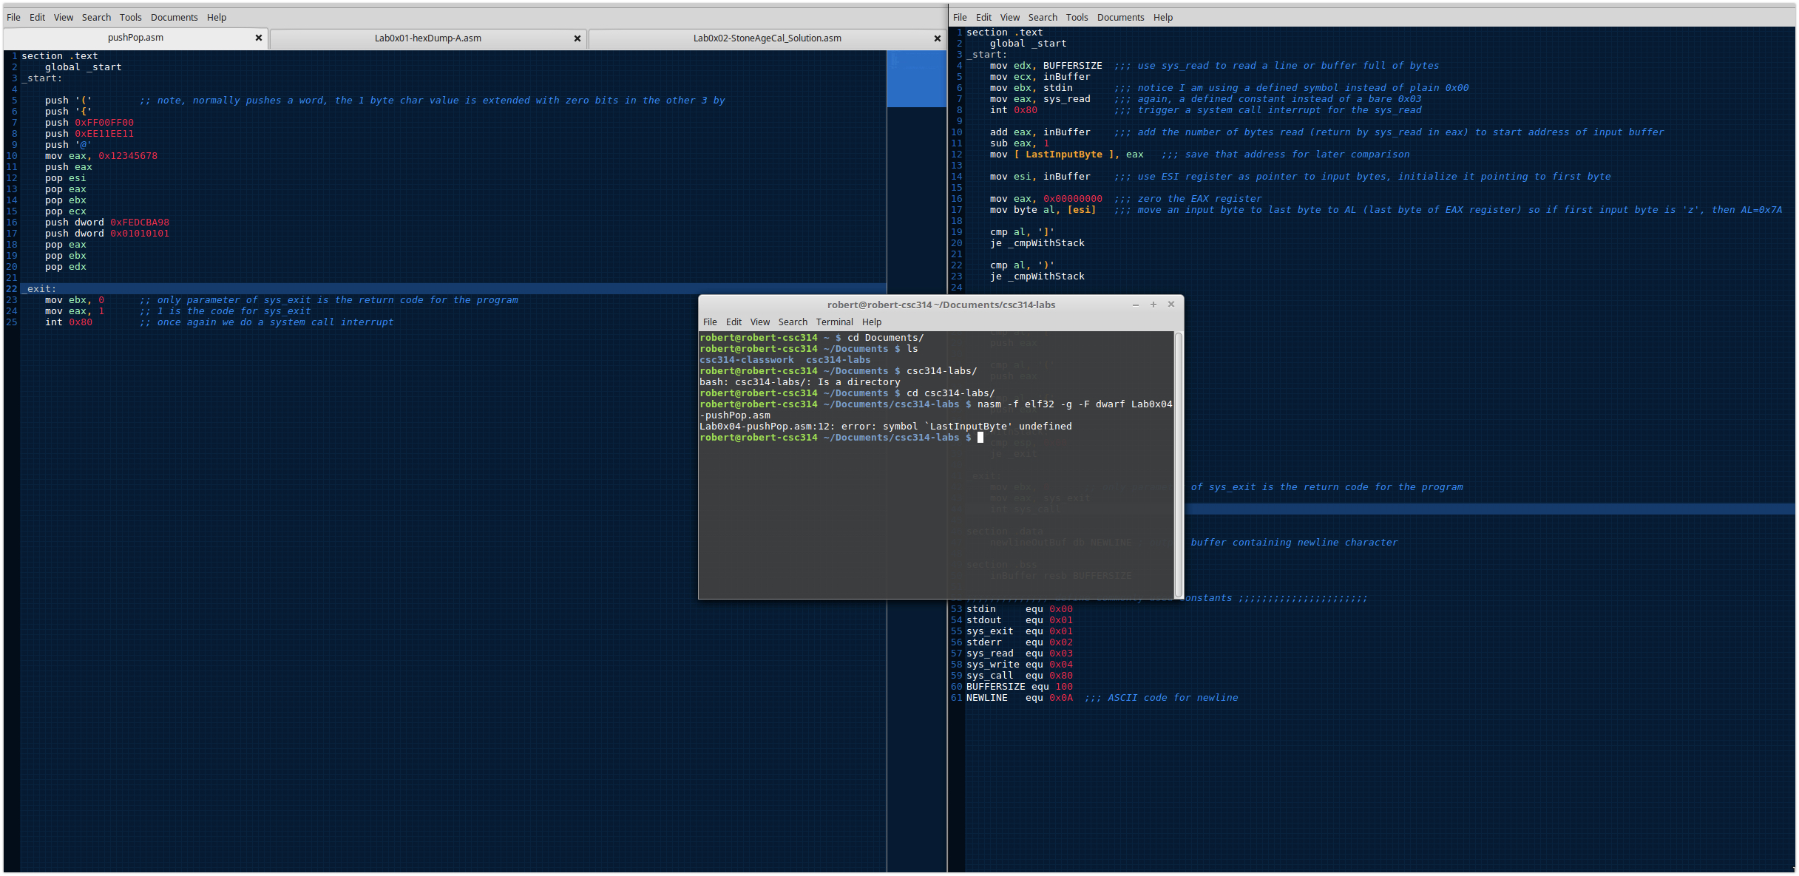

Testing Algorithm

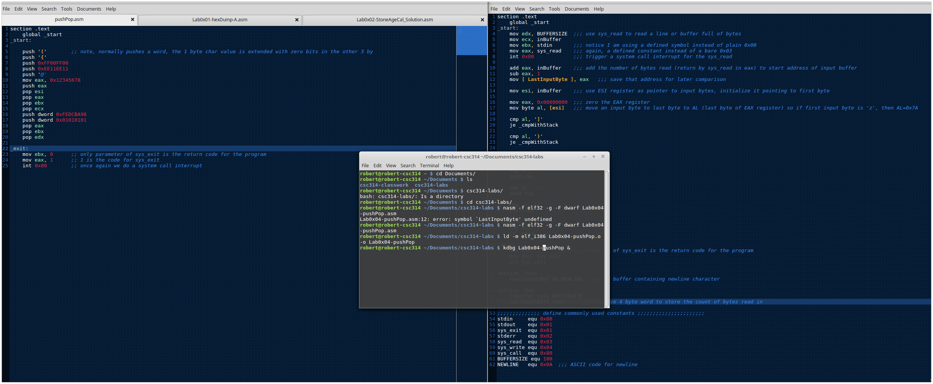

Testing Algorithm

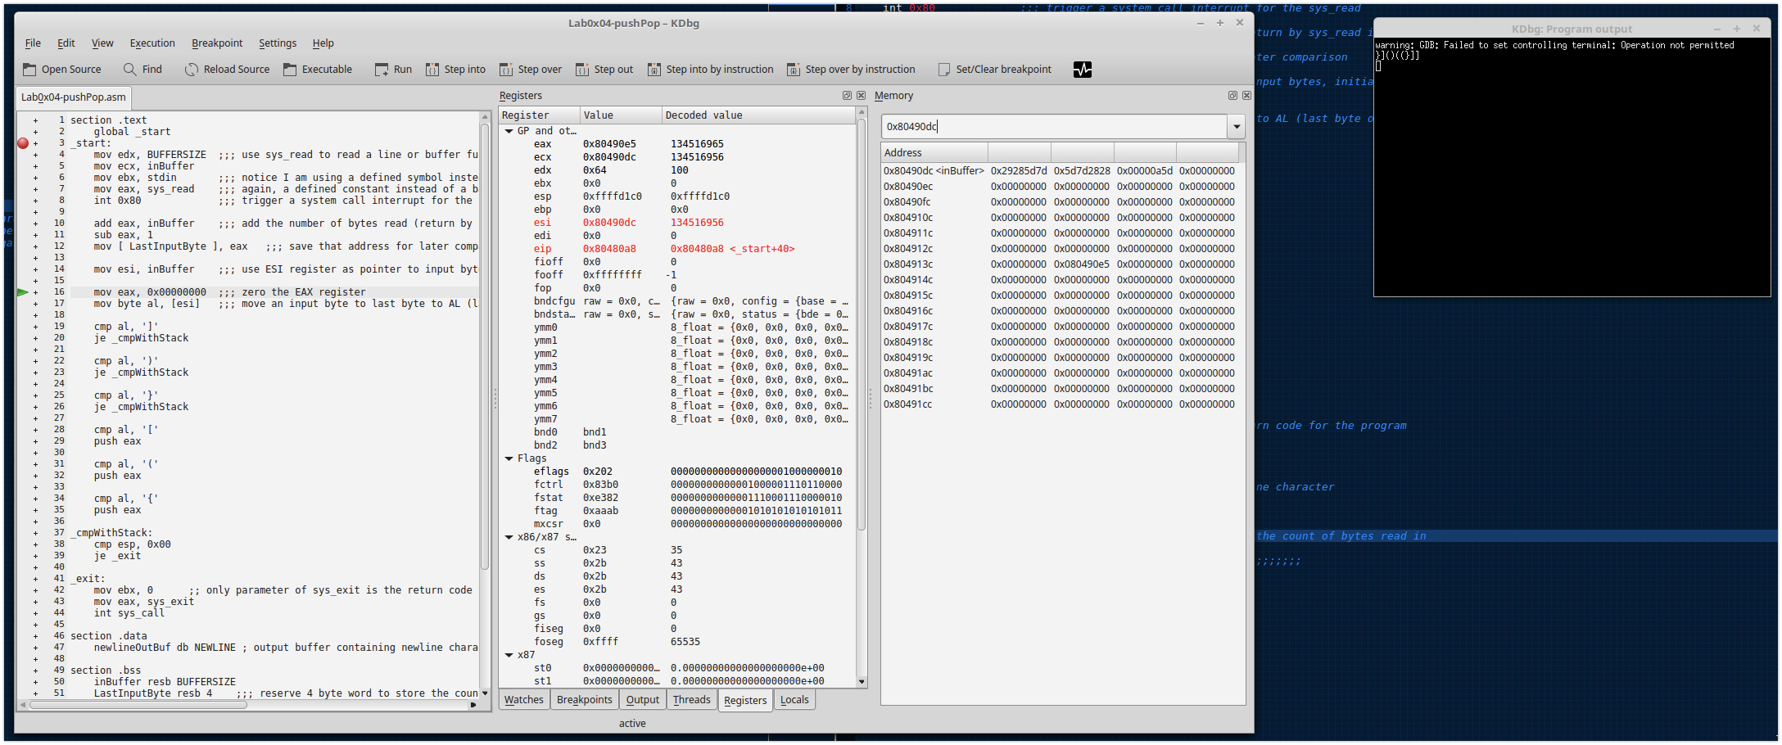

Testing Algorithm

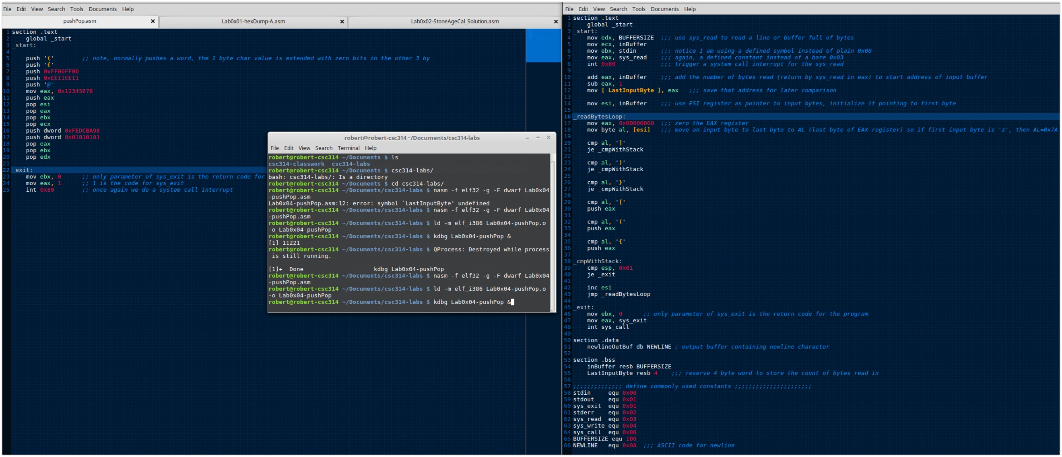

Testing Algorithm

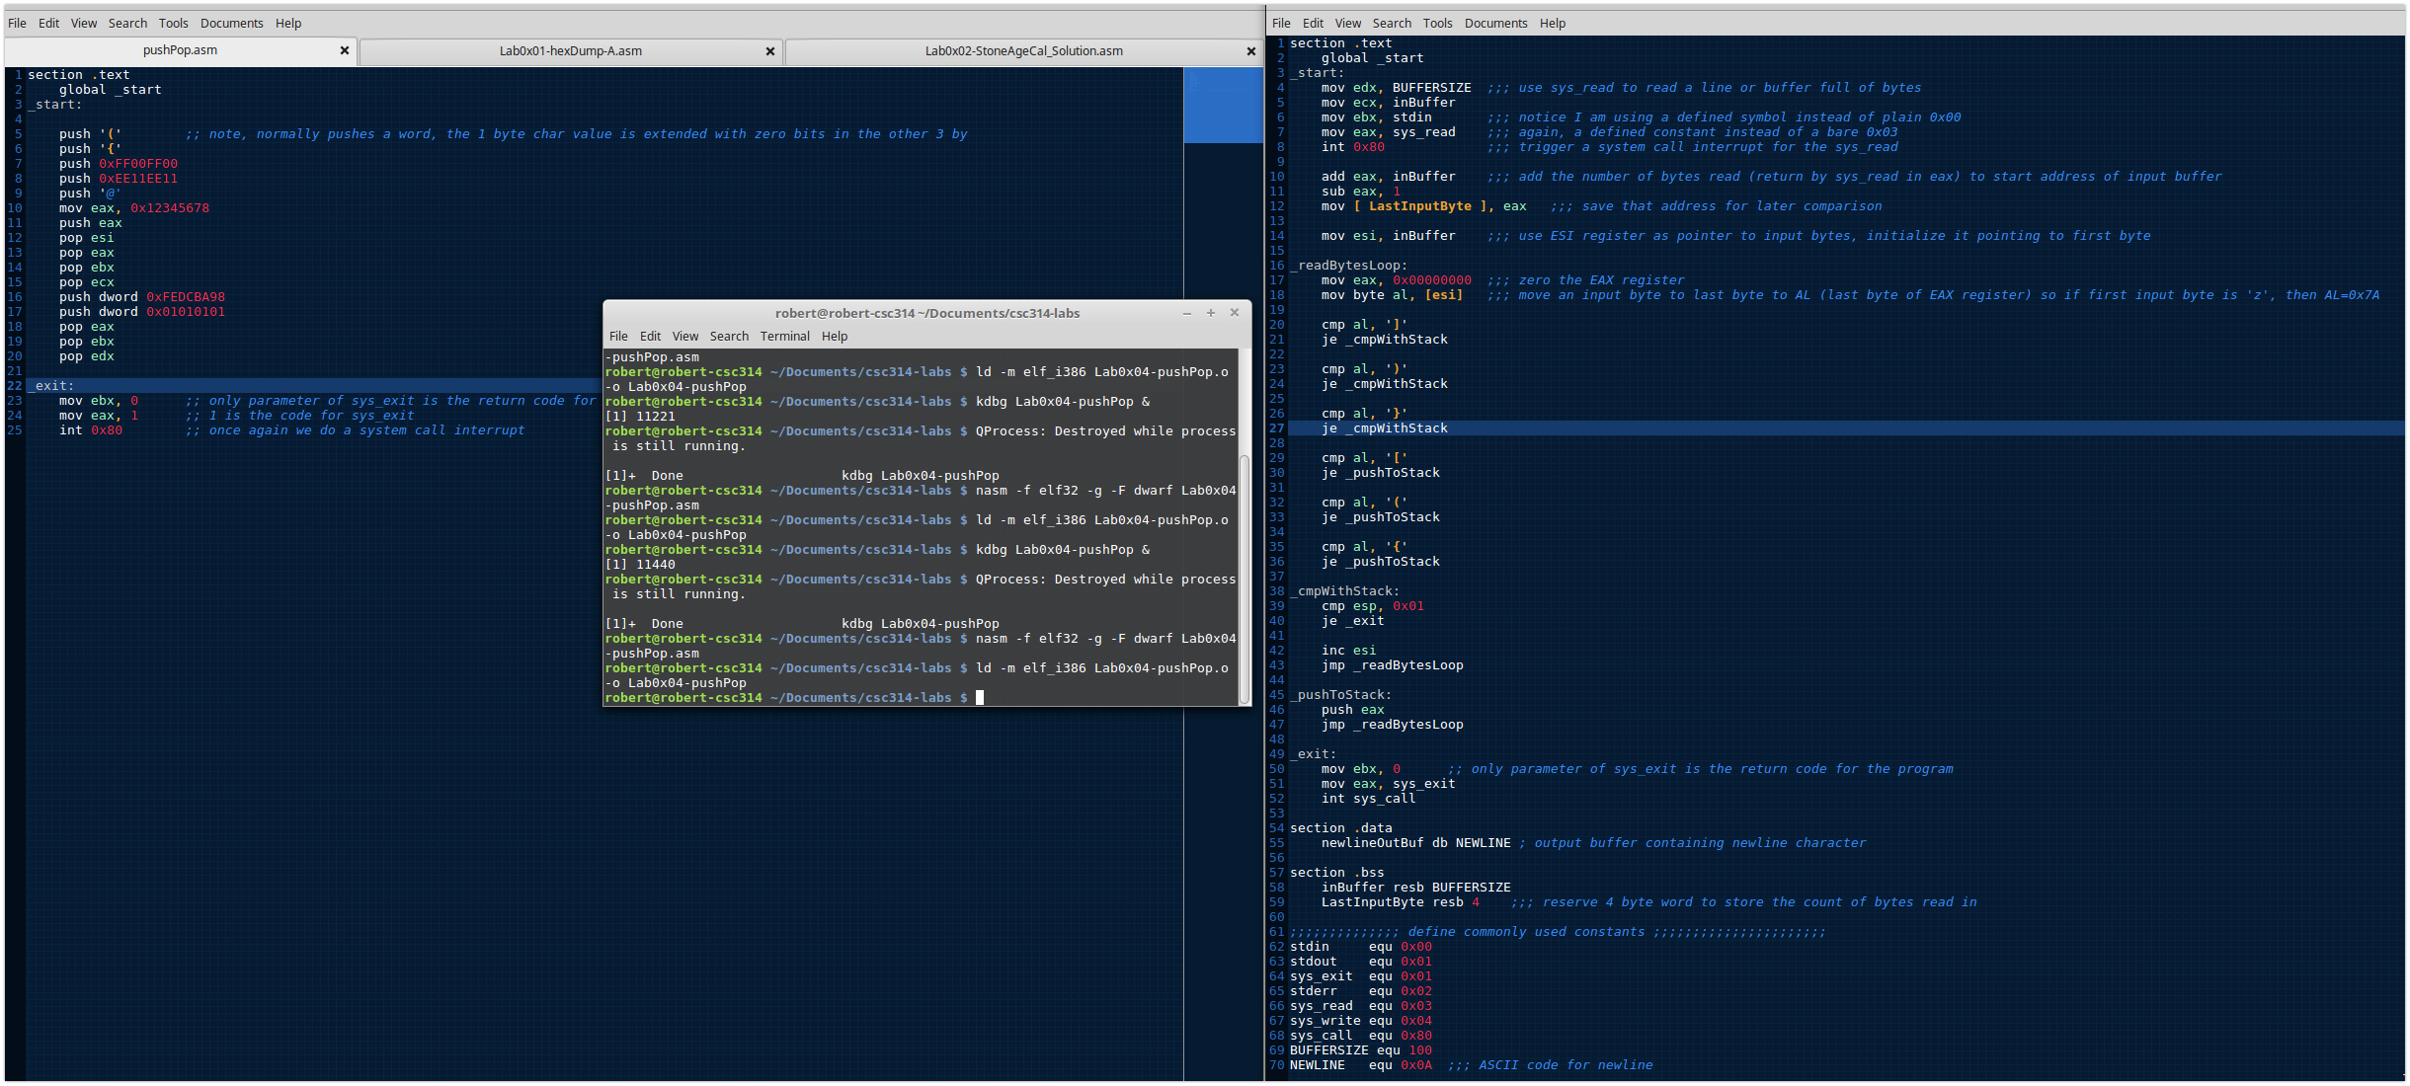

Testing Algorithm

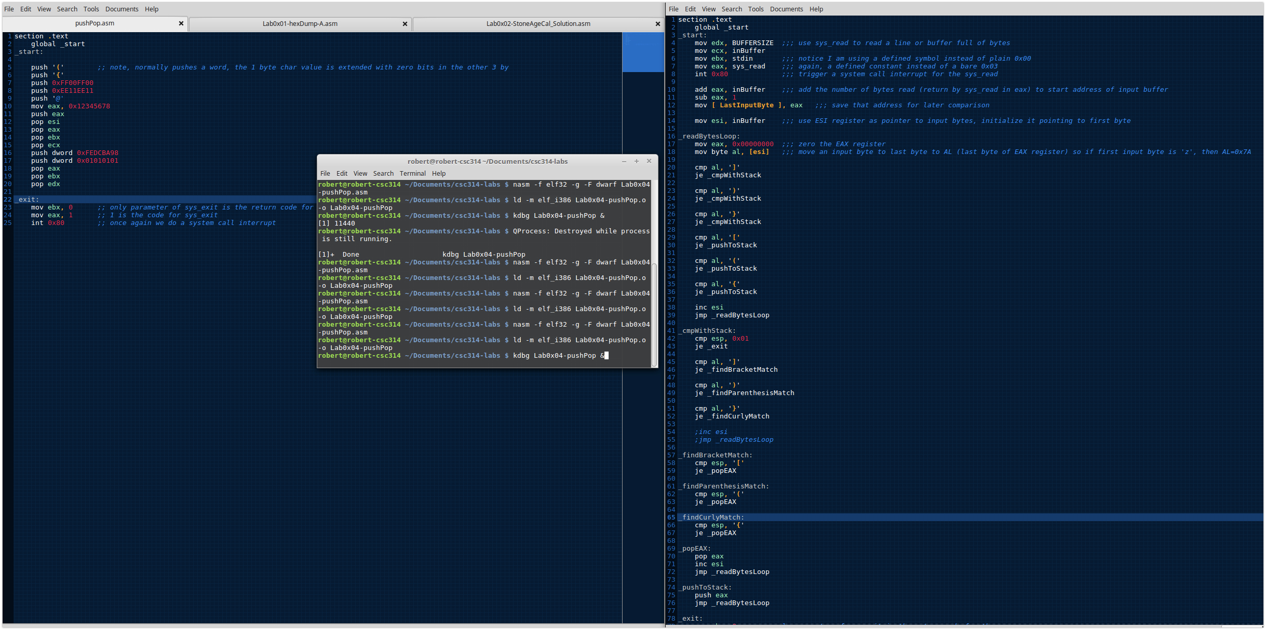

Testing Algorithm

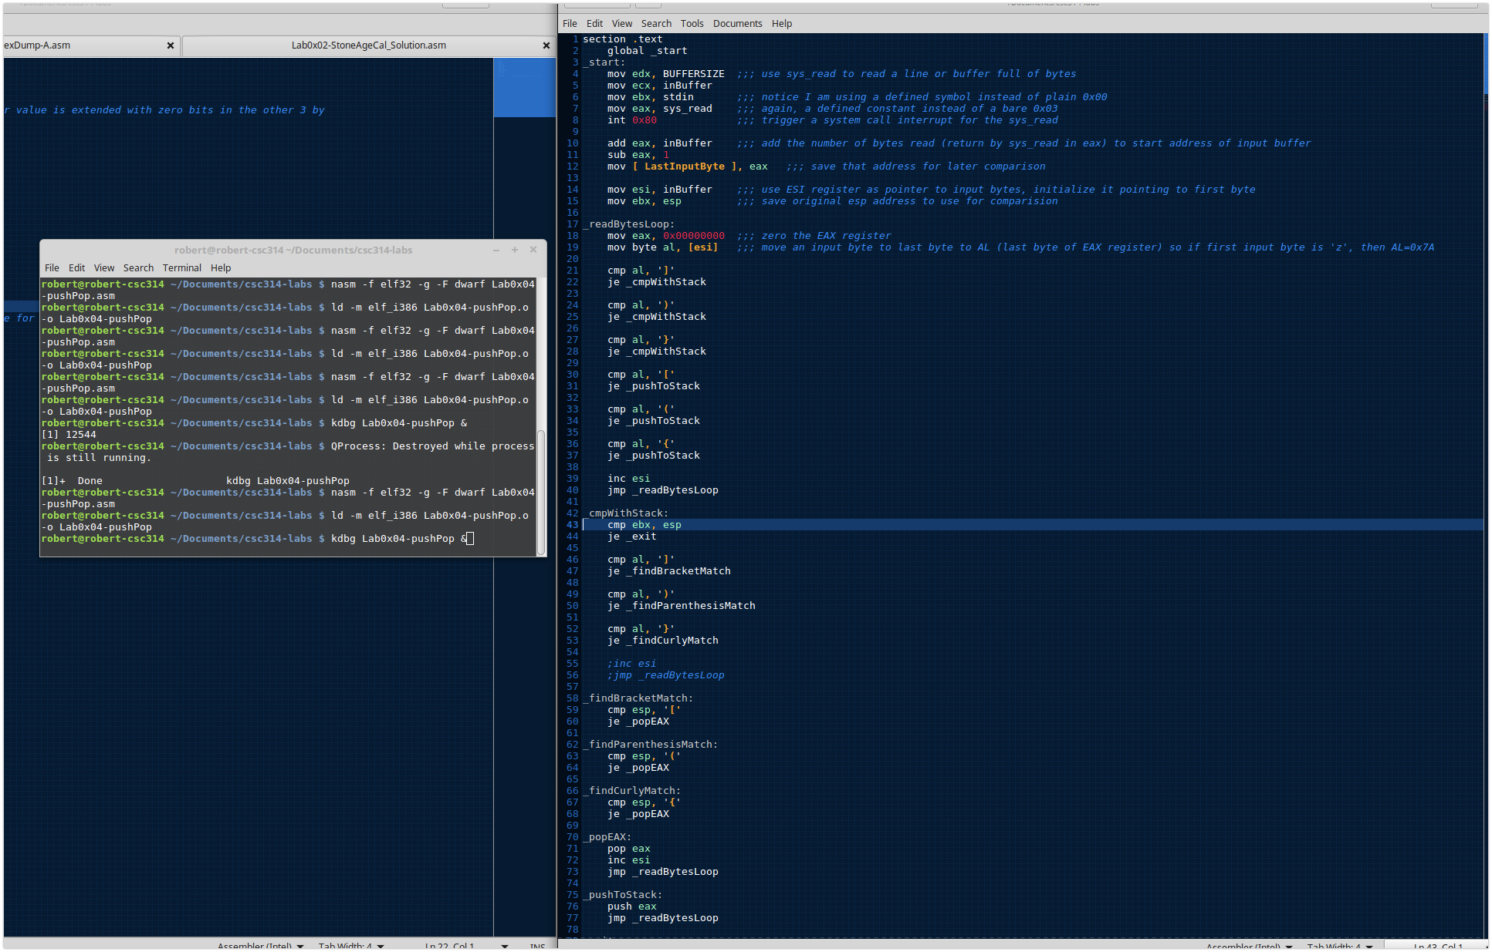

Edit _cmpWithStack

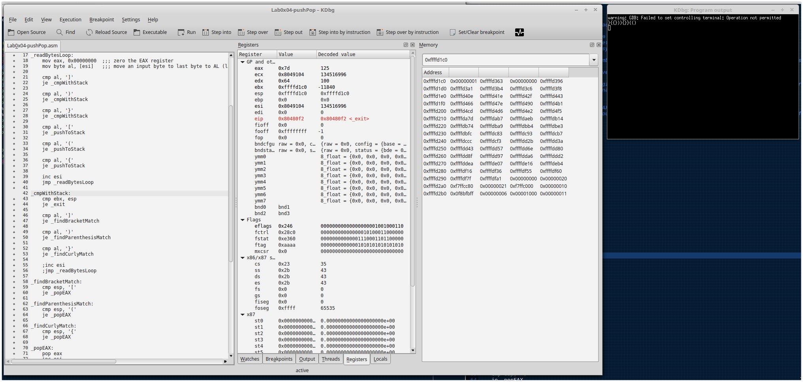

Infinite loop found

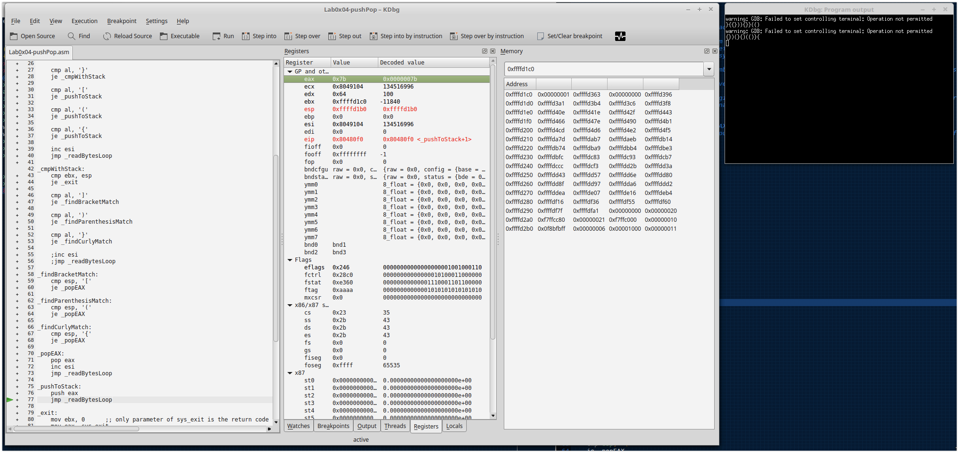

Fixed infinite loop

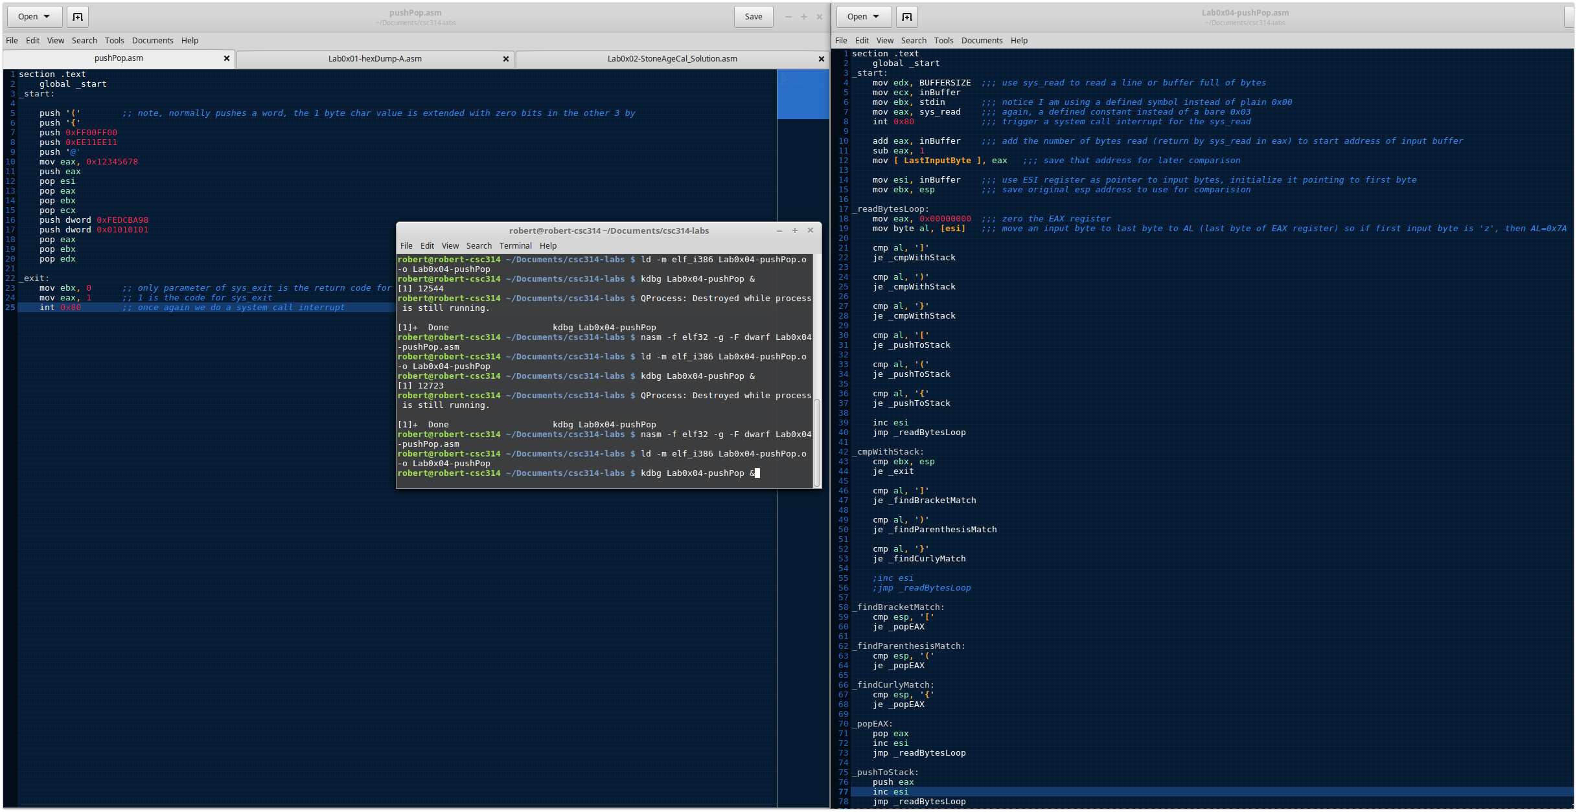

Working with _findCurlyMatch it didn’t work at first

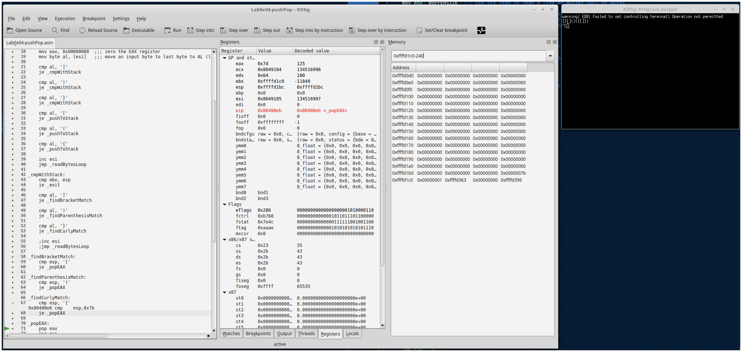

Editing _findCurlyMatch

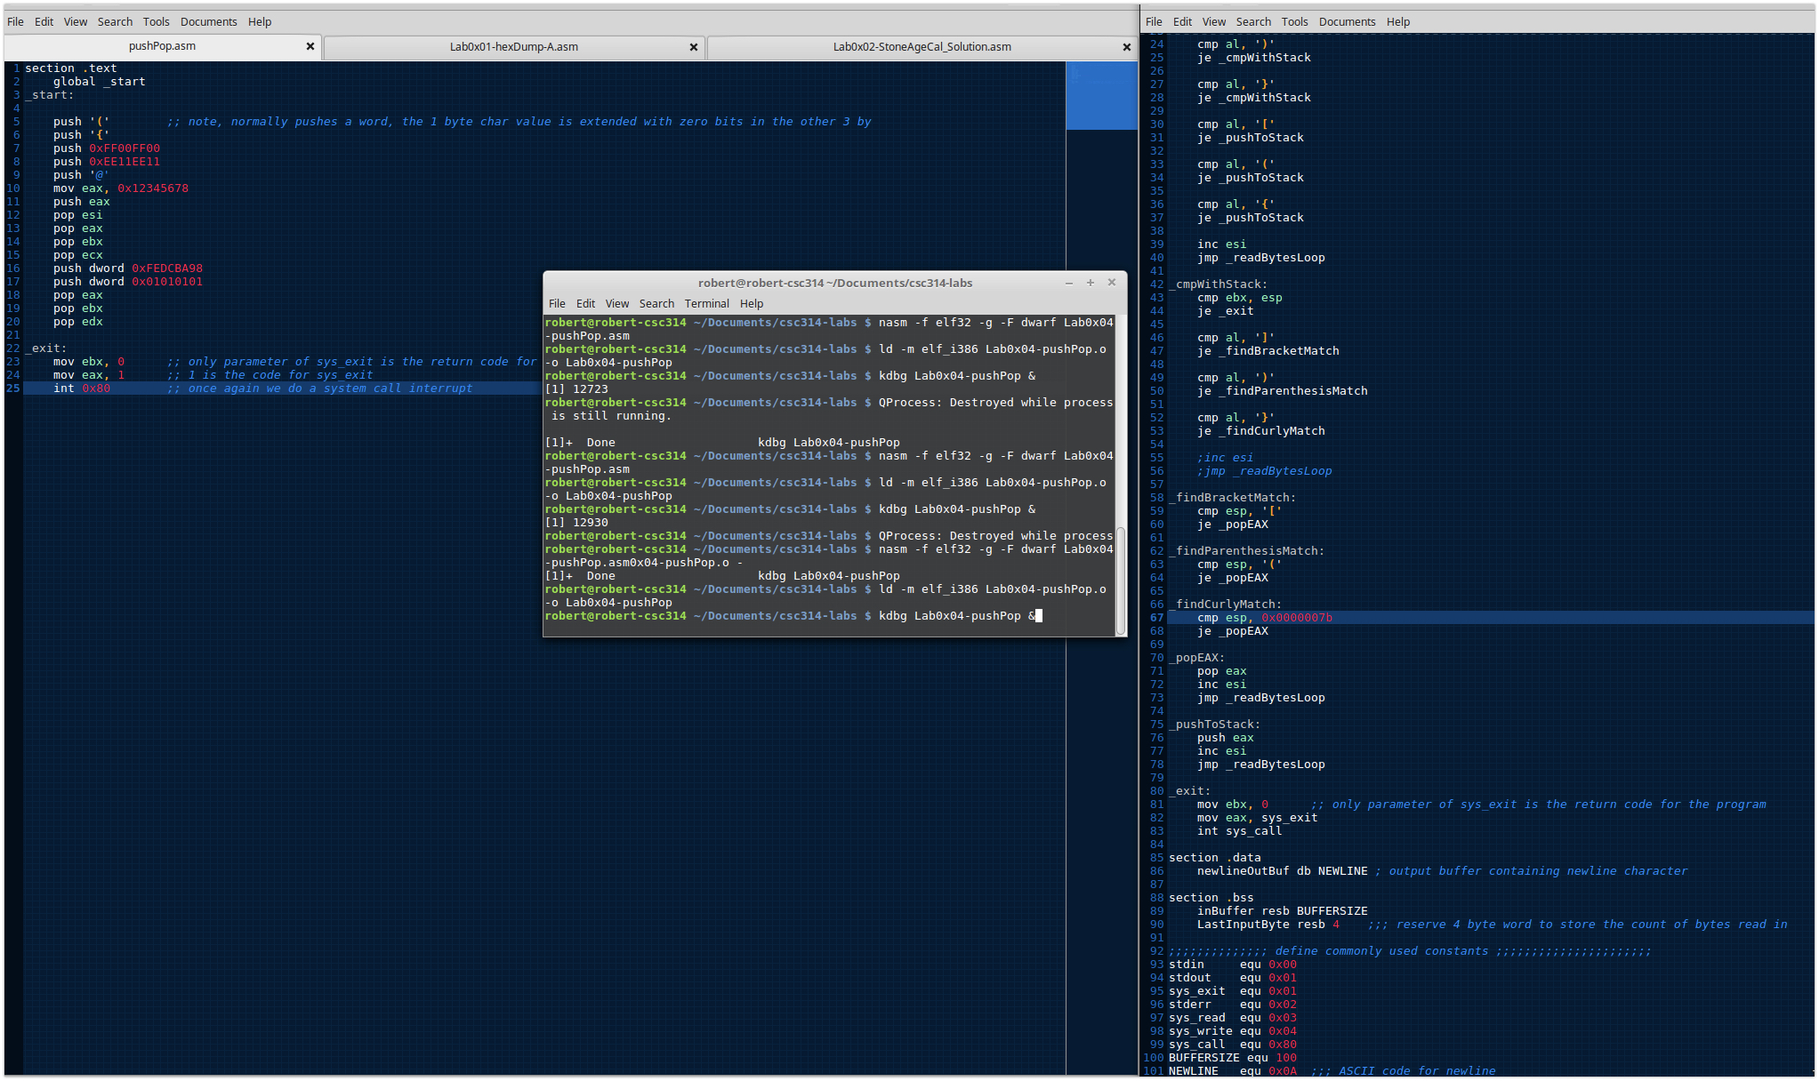

_findCurlyMatch isn’t working as expected

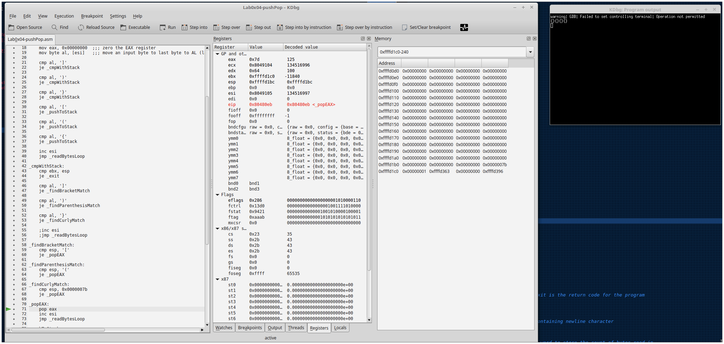

Fixing _findCurlyMatch

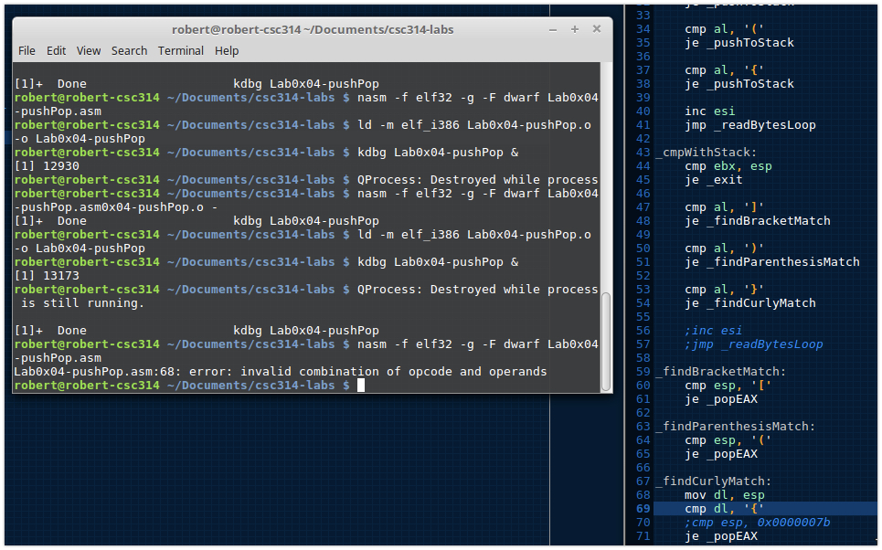

Fixed _findCurlyMatch

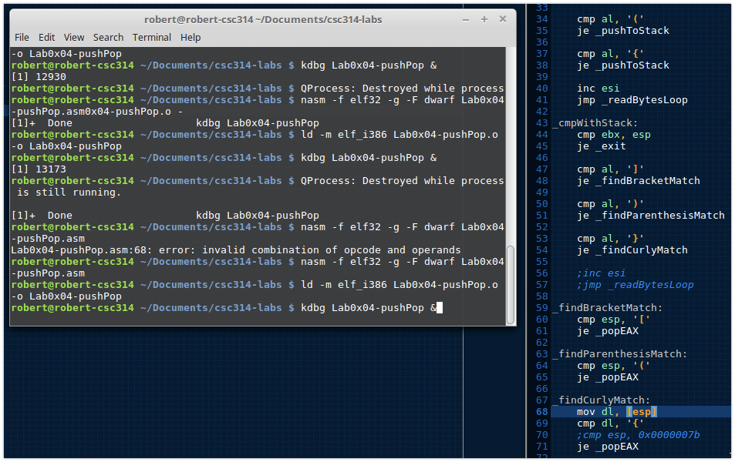

Adding exit messages

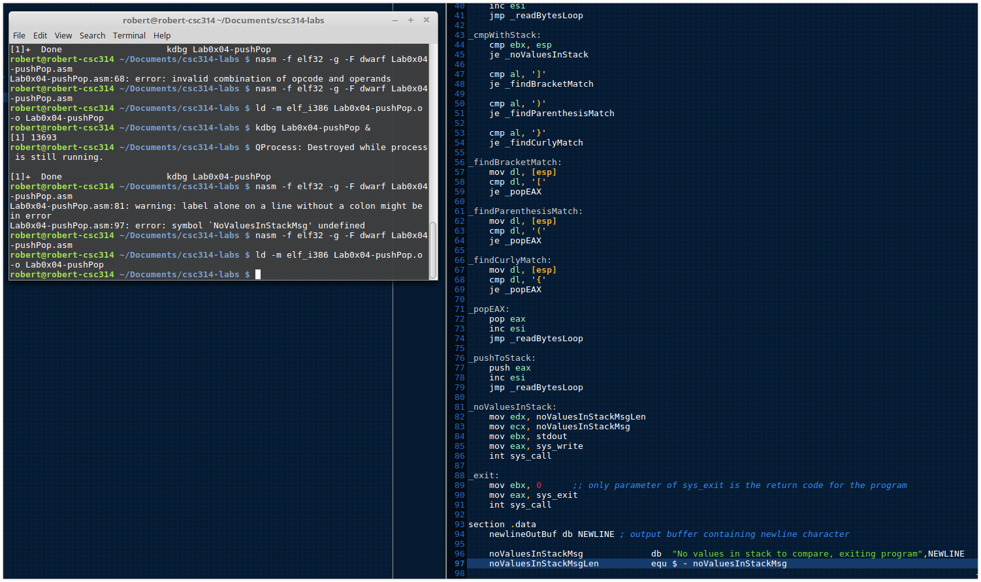

Testing exiting messages some do not have values

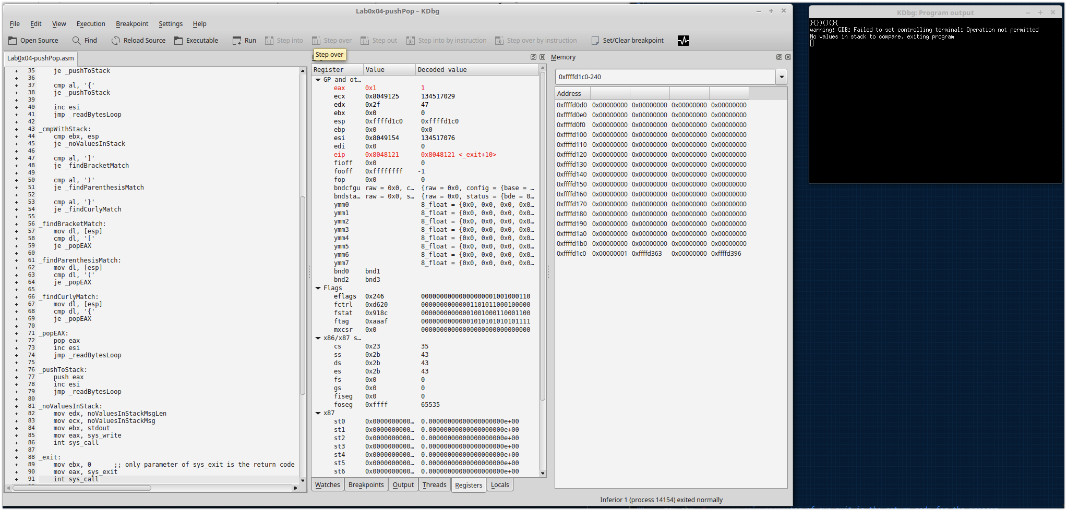

noBracketFound has an error message I need to fix

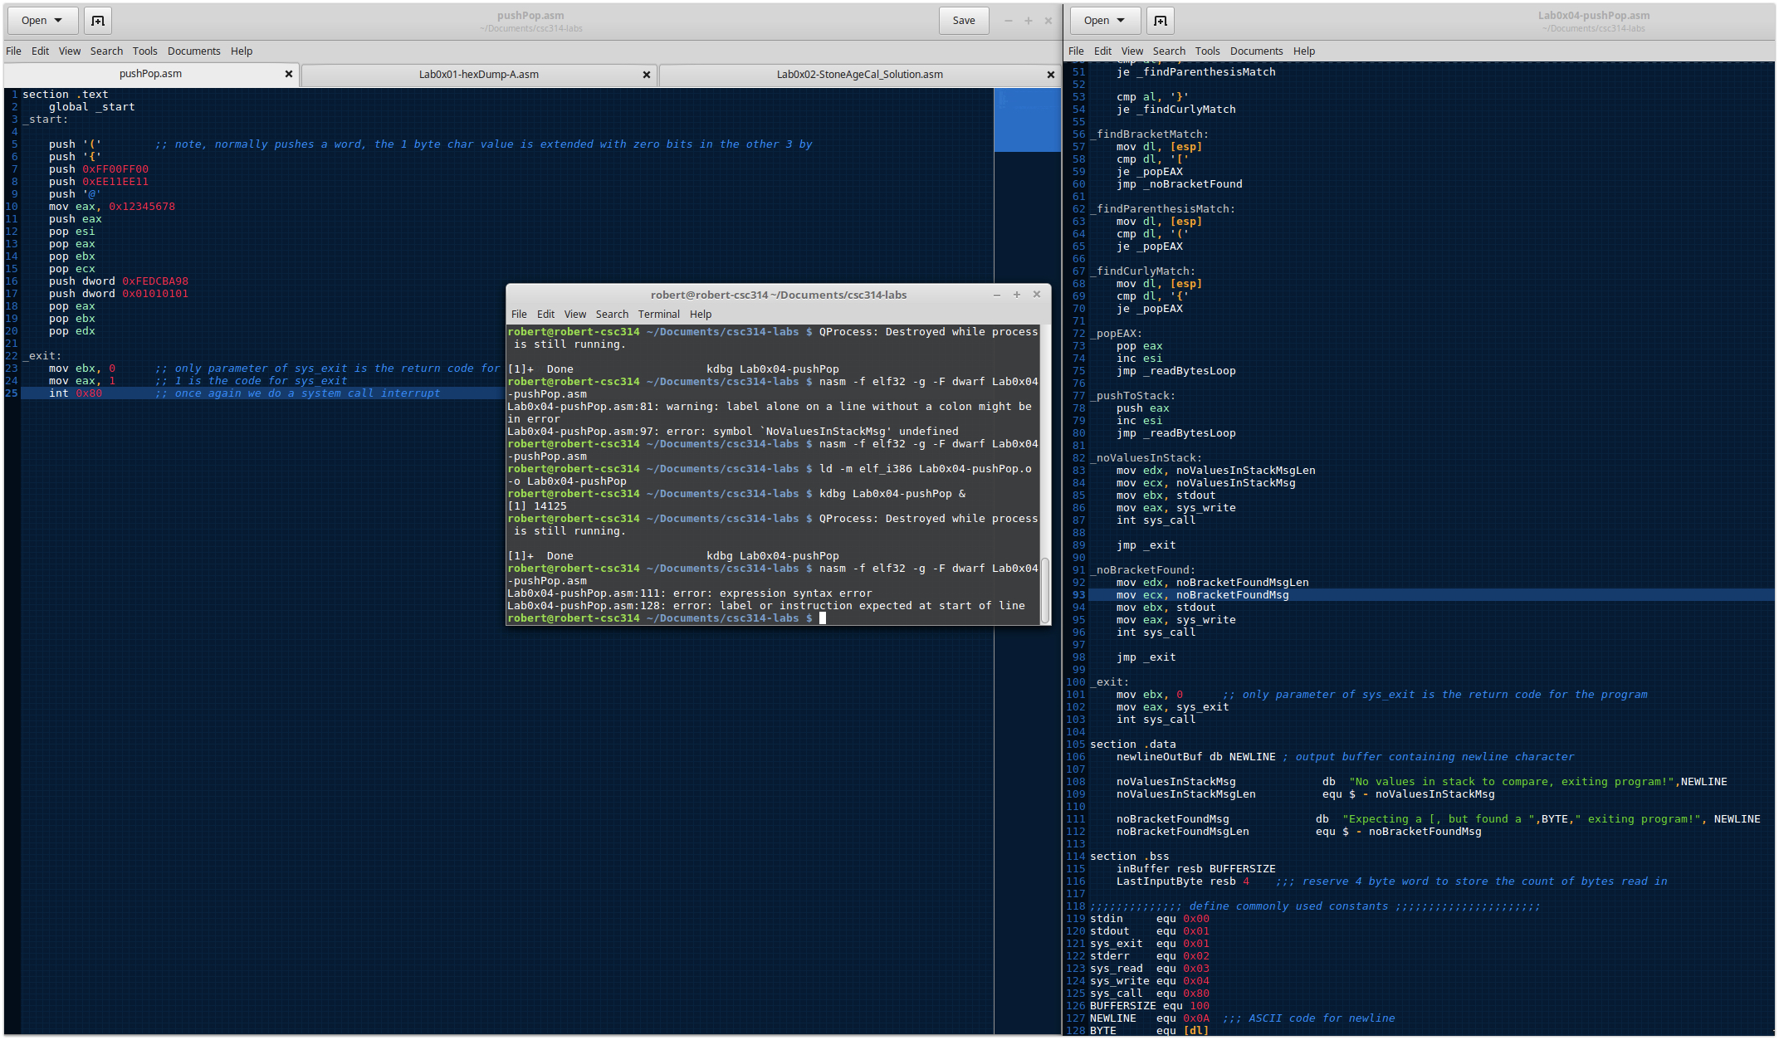

Working through noBracketFound error message

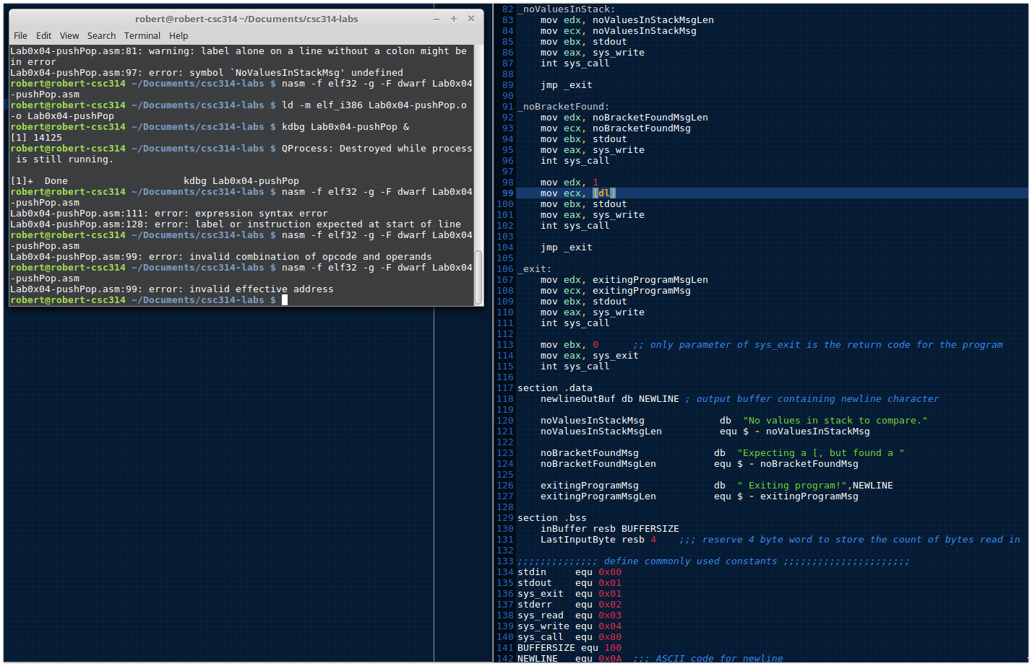

Fixed noBracketFound

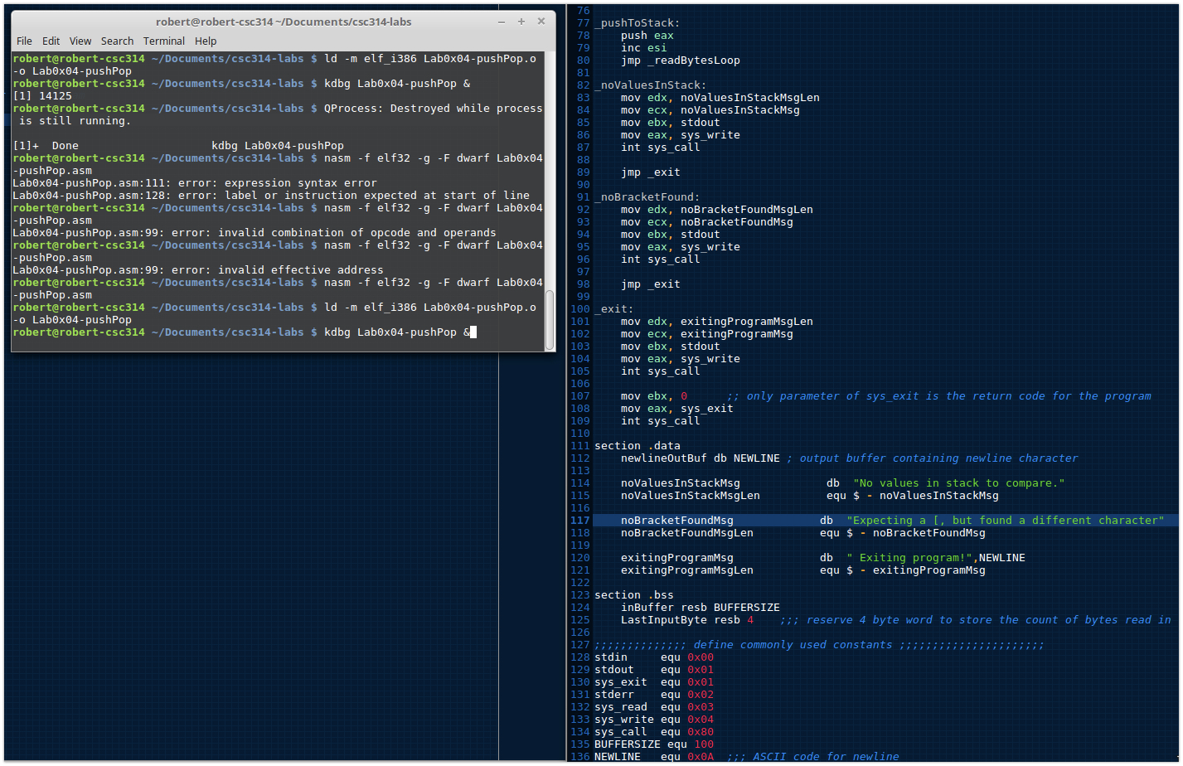

Program works without exit jumps

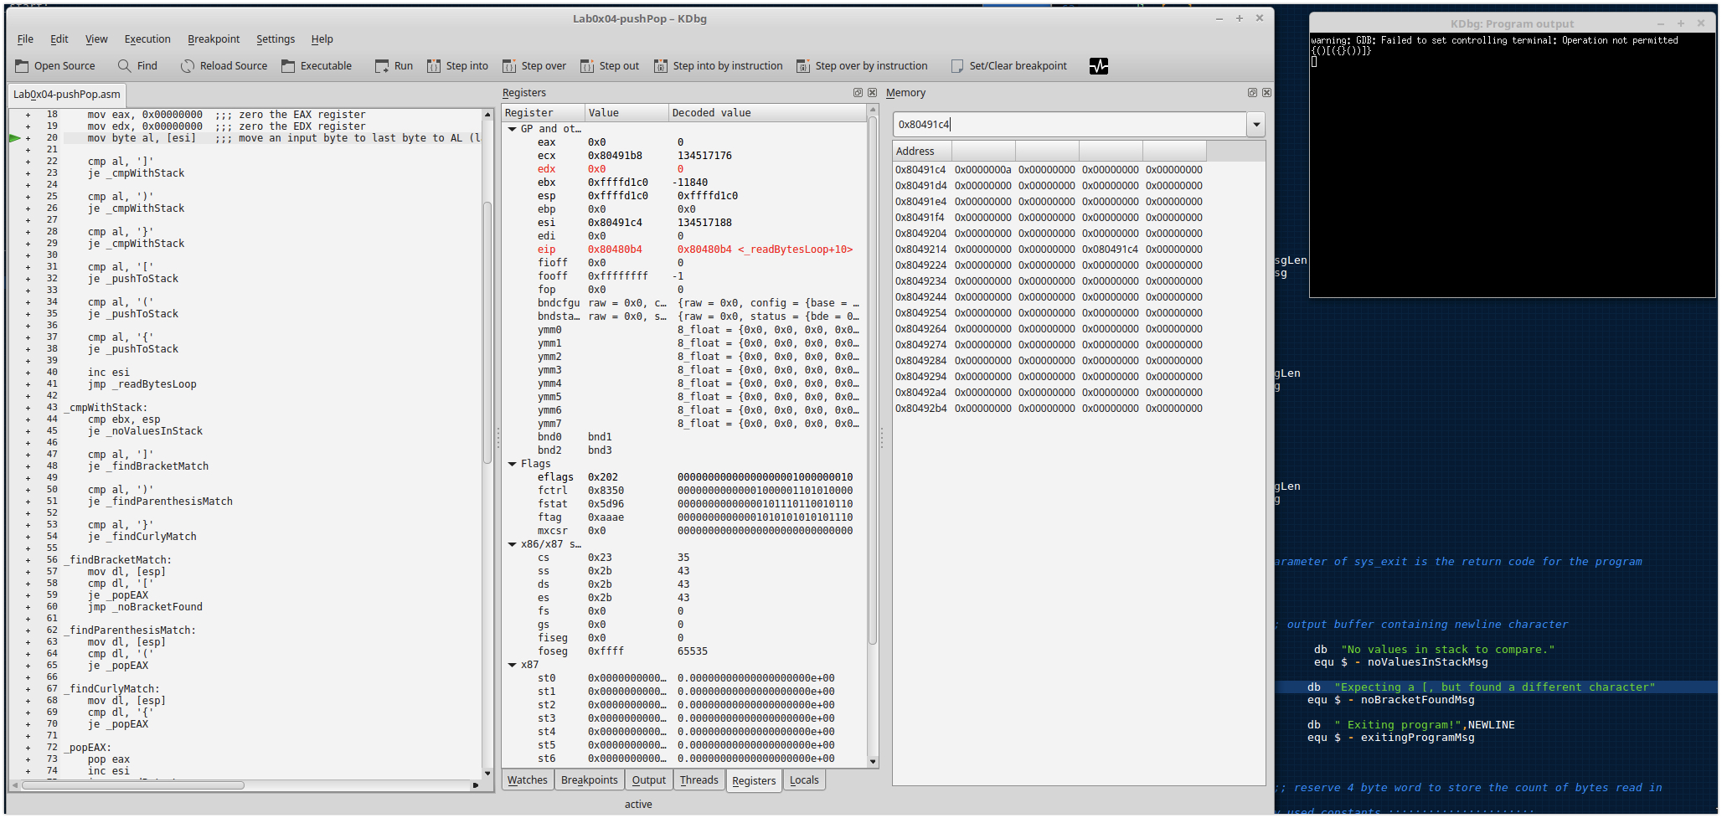

Final testing of program and messages

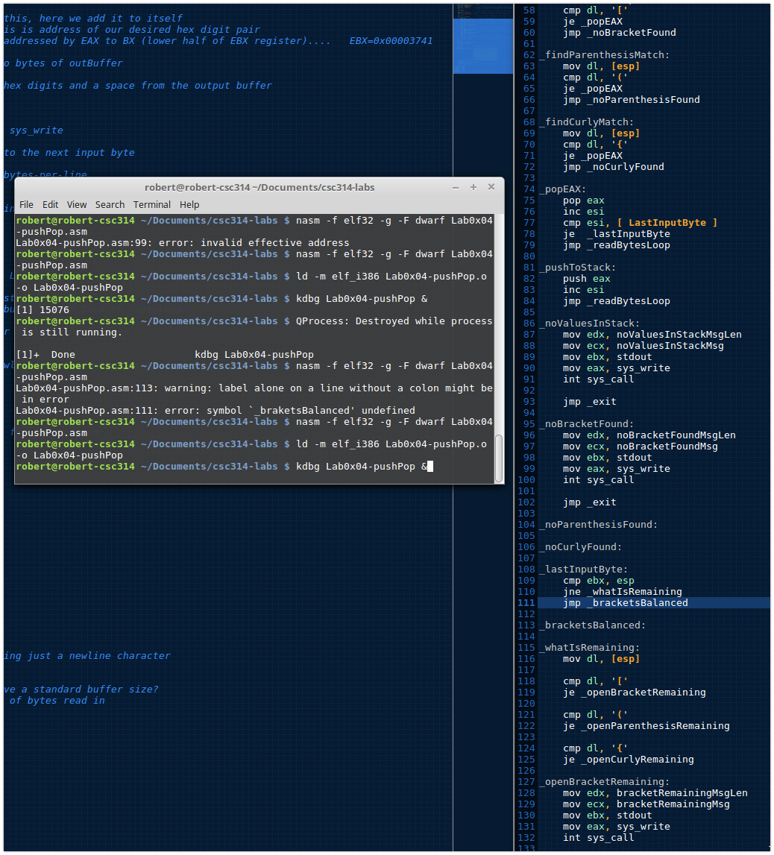

Working through final bugs

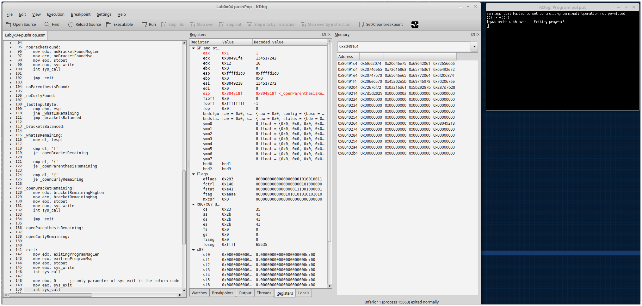

Still working through final bugs

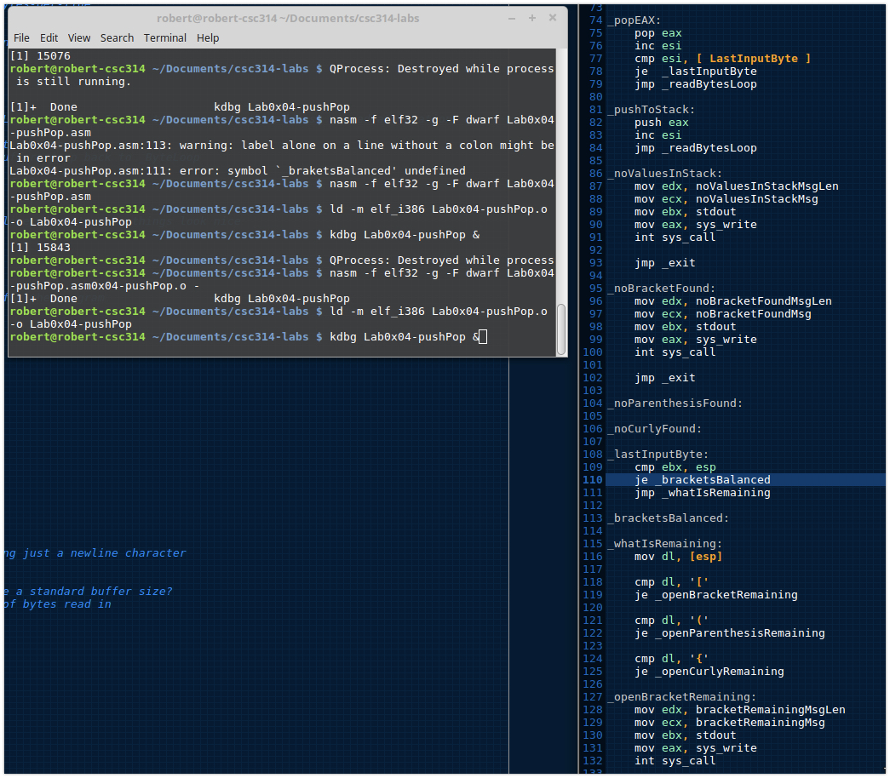

Last testing prior to submitting program Lab0x04

